

De La Salle University

Gokongwei College of Engineering

Electronics and Communications Engineering Department

**LBYCP29 Experiment 1**

Submitted By:

**Jan Carlo D. Rabacca**

**Suzette Dela Cruz**

**Marc Chiu**

Submitted To:

**Engr. Melvin Cabatuan**

Date:

**September 9, 2015**

Linear Regression

Jan Carlo D. Rabacca

11106344

Suzette Dela Cruz

11118113

Marc Chiu

11114525

# Introduction

Linear Regression is method to analyze data which consist of an independent variable and a correspondent dependent variable. This method produces regression estimates that are used to explain relationship between the two variables [1].

# . Procedures

## The first step is to load data to analyze, in this experiment we have,



1. Next, set the training examples equal to the length of y which will be used to develop the linear regression model, concatenate this training examples to the matrix x and lastly we initialize the value of thetas.



1. After that, define the learning rate and maximum iterations.



1. Lastly, execute the gradient descent by applying the formula given.

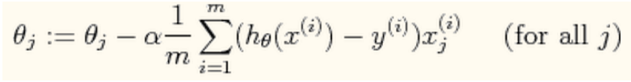

The h is equal to the product of theta and x excuted in this manner,



To obtain the value where theta converges, use for-loop until the maximum iterations.

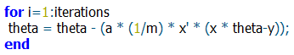

1. To predict data, make use of the theta values.



This will predict the height in meters given the ages 3.5 and 7.

1. Plot a 3D-plot surface model of error or cost function.

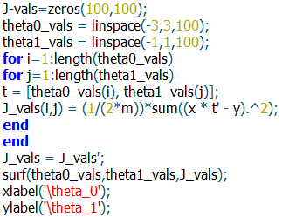

# Data and Results

### 1st Procedure

## First Iteration:

ɵ1 = 0.074528 ɵ2 = 0.38002

## 1500th Iteration:

ɵ1 = 0.750150 ɵ2 = 0.063883

### 2nd Procedure

## Plot:

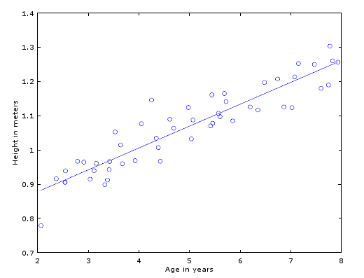

### 3rd Procedure

Age: 3.5 Height: 0.9739 m

Age: 7 Height: 1.1973 m

### 3D Plot

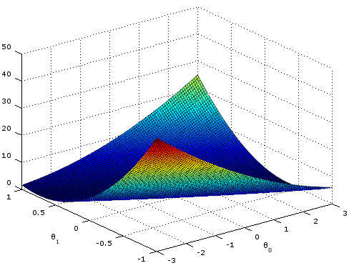

### Problem

1. Same with procedure with the experiment however with different data values.

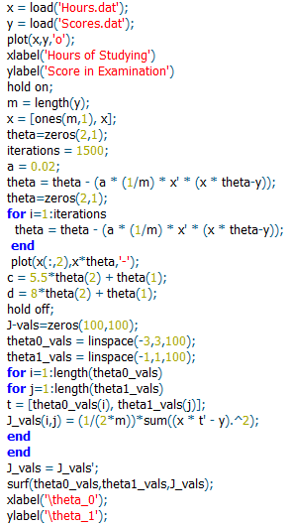

1. 1st Procedure

## First Iteration:

ɵ1 = 1.1088 ɵ2 = 6.4592

## 1500th Iteration:

ɵ1 = 17.3259 ɵ2 = 7.3819

1. 2nd Procedure

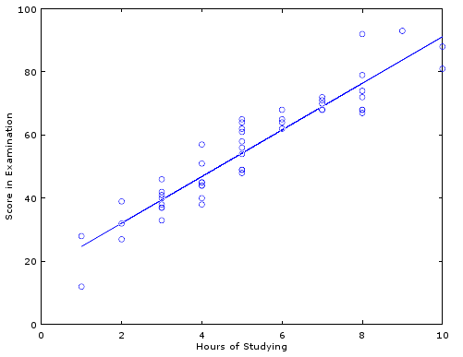

1. 3rd Procedure

Hours spent studying: 5.5 Score: 57.9

Hours spent studying: 8 Score: 76.4

1. 3D Plot

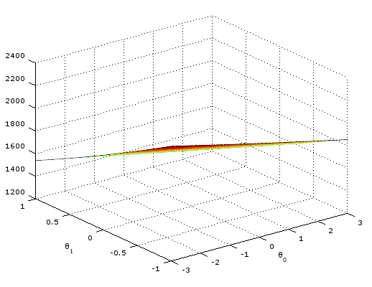

1. Questions to answer

The hypotheses is the line going through the data values and the ones the make up this line are the theta 1 and 2, to check and improve the hypotheses function or the line passing through the data and this is what gradient descent is and plotting a 3D model shows the accuracy.

# Analysis and conclusion

In the formula, there are only two major variables in this experiment that can affect the model greatly, the learning curve and the maximum iteration. In example, the data from the experiment is on a decimal places however the data on the problem is on the tenth’s places, the learning rate, alpha was reduced on the problem because if the alpha was left to be 0.07 with data on the tenth’s place, the line on the plot generated by the gradient descent formula will not match the data, moreover, the maximum iterations does not affect that line that much however, on the problem part, if the maximum iteration is to be reduced, it leans more towards to x-axis.

Linear Regression is a very useful to estimate values based on independent and dependent variables. This method of analyzing data is applicable to many areas and a good example was the data presented on the problem part where the score can be estimated based on the hours spent studying of a student.

# REFERENCE

[1] Stattrek.com, 'Linear Regression', 2015. [Online]. Available: http://stattrek.com/regression/linear-regression.aspx. [Accessed: 08- Sep- 2015].

[2]G. implementation, 'Gradient Descent Matlab implementation', Stackoverflow.com, 2015. [Online]. Available: http://stackoverflow.com/questions/21799435/gradient-descent-matlab-implementation. [Accessed: 08- Sep- 2015].

[3]O. Niburski, 'Hello.Oskar', Raksonibs.github.io, 2015. [Online]. Available: http://raksonibs.github.io/blog/22/. [Accessed: 08- Sep- 2015].